DEPARTMENT OF PUBLIC ADMINISTRATION AND MANAGEMENT
RESEARCH FOCUS AREAS FOR MASTER’S AND DOCTORAL STUDIES 2027
FOCUS AREA: PUBLIC FINANCE
Department |  |  | Public Administration and Management
Discipline |  |  | Public Administration
Research Focus Area |  |  | Public Finance
Capacity for 2027 |  |  | 2 PHD 4 masters
Supervision Team details: | Academic Profile |  |  | Capacity for 2027
Prof V Sambo  (Contact person for this focus area)  Office: Nkoana Simon Radipere: 4-117  Email: esambovt@unisa.ac.za  ORCID ID: https://orcid.org/0000-0002-3538-6041 | Prof Vaola Sambo is currently an Associate Professor in the Department of Public Administration and Management. Her areas of specialisation are Public Finance and Public Policy implementation.  Her research falls within principle ten of the United Nations (UN) Global Compact and focuses on the following: 1. How the implementation of internal audit functions in public institutions can assist management in instituting internal controls for the reduction of corruption. To this end, her research also offers recommendations for policy amendments with a view towards having policies that support the reduction of corruption. 2. Lessons from governance and accountability theoretical lenses on avoiding malfeasance that has to do with amongst others interference by the Executive arm of the state on administrative matters such as supply chain processes which results in financial losses to the state. Furthermore, Prof Sambo writes on Development Finance matters and the financial management of State-Owned Enterprises. |  |  | Currently supervising 5 Doctoral and 3 Masters candidates  Capacity for 2027: 2 Doctoral and one Masters candidates
Mr A Matthews  Office: Nkoana Simon Radipere building: 4-114  Email: amatthews@unisa.ac.za | Mr Matthews is currently employed as a Lecturer in the Department of Public Administration and Management. His fields of speciality and interest include the following:  Project Management, Human Resource Management, Training and Development, and Public Finance |  |  | Currently supervising 4 students
Model of supervision | Candidates will be allocated to a supervisor but will be required to work independently within the requirements of higher degree studies.
Selection criteria: Master’s/Doctorate | In addition to the admission criteria contained in the myChoice brochure, potential students are required to prepare a five-page expression of interest essay describing the following:  - Topic (½ page)  - Short literature review (2 pages)  - Potential contribution of the study (½ page)  - Potential unit of analysis (½ page)  - Access to the research context (½ page)  - Personal motivation to pursue studies in this topic (½ page)  List of references (use Harvard referencing method)
Selection Procedure | - Apply for a student number  - Apply for a space in the research focus area using the online application process.  - Once acceptance in the research focus area has been confirmed, you may register for your studies.  Selection of candidates will be in line with Section 37 of the Higher Education Act 101 of 1997 to provide appropriate measures for the redress of past inequalities and to provide clear assessment criteria to avoid any unfair discrimination. Applicants will also receive feedback on their submissions to empower unsuccessful candidates to improve future readmission submissions.  The following criteria will be applied to assess the expression of interest essay:  - Academic merit: Quality in terms of originality, significance and rigour and impacts in terms of their reach and significance.  - Evidence of higher order thinking: The candidate’s skills and abilities in analysing, synthesizing, applying, and evaluating information.  - Academic writing skills: The extent to which the essay convey coherent and well-developed arguments that are supported with relevant, detailed and convincing evidence; the logically sequence of paragraphs with content-based transitions; the use of appropriate diction and tone and constructively vary sentence structures, and the use of correct grammar, punctuation, spelling and syntax.  Academic and professional experience: Strengths and relevance relative to the candidate’s opportunities (impact).
Research scope | To explore major topics and subtopics in the administration and government of public money: including the following: the role of Parliament, intergovernmental financial relations, budgeting (including Punctuated Equilibrium Theory) and public procurement.
Reading:  Subject Field | This is a selection of articles and/or books in this research focus area. Further reading over and above these is essential:  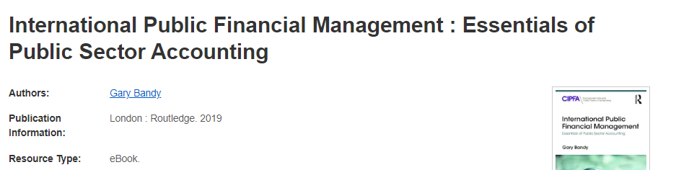  Link: http://0-search.ebscohost.com.oasis.unisa.ac.za/login.aspx?direct=true&db=nlebk&AN=1966054&site=eds-live&scope=site  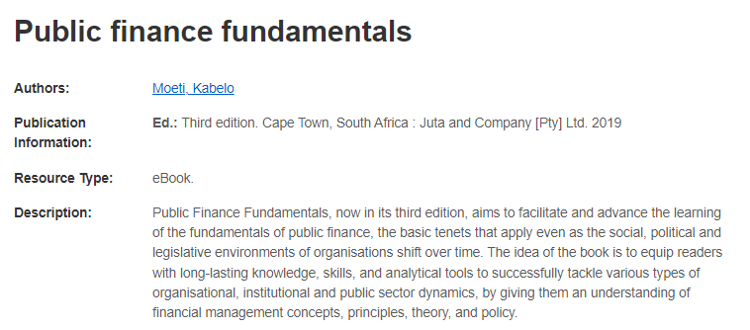  http://0-search.ebscohost.com.oasis.unisa.ac.za/login.aspx?direct=true&db=nlebk&AN=2381996&site=eds-live&scope=site  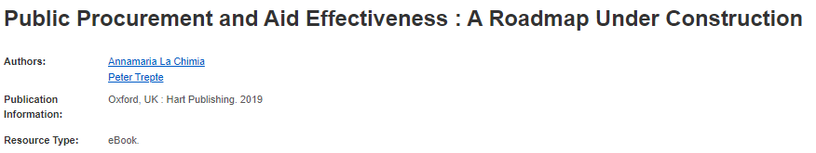  http://0-search.ebscohost.com.oasis.unisa.ac.za/login.aspx?direct=true&db=nlebk&AN=2179171&site=eds-live&scope=site  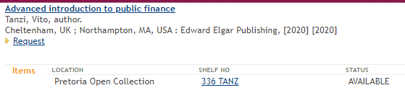  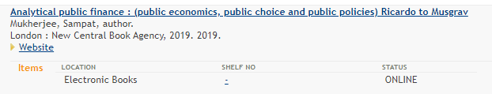  http://0-search.ebscohost.com.oasis.unisa.ac.za/login.aspx?direct=true&db=nlebk&AN=2239471&site=ehost-live&scope=site    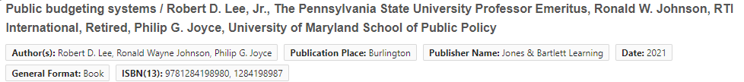  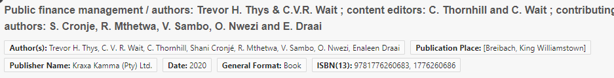  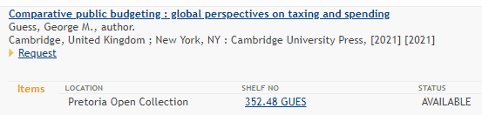    https://0-ebookcentral-proquest-com.oasis.unisa.ac.za/lib/unisa1-ebooks/detail.action?docID=6341102  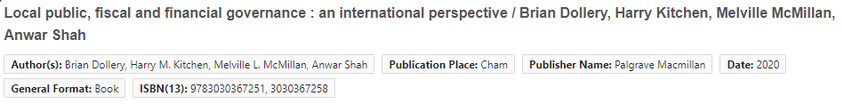    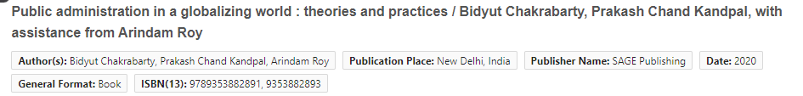
Reading:  Research Methodology |   https://oasis.unisa.ac.za/record=b2677243~S1        EBook access: https://oasis.unisa.ac.za/record=b2734335~S1
Potential M&D research focus areas or research projects
Unit of Analysis |  | Research Focus
Public Finance in general |  | See the research scope above.
Government spending as a fundamental of public financial administration and management |  | See the research scope above.

Please note that consulting the research focus area leader is no assurance that your application will be approved. If, however, your application is approved, it is also not a guarantee that he/she will be allocated as your supervisor.

